Practical 3

Question 1:

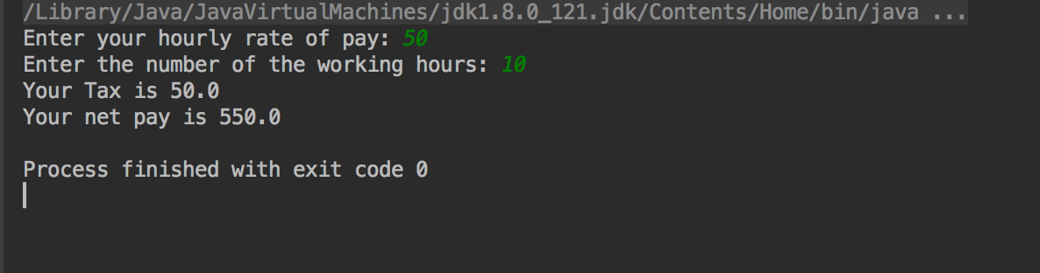

Question 2:

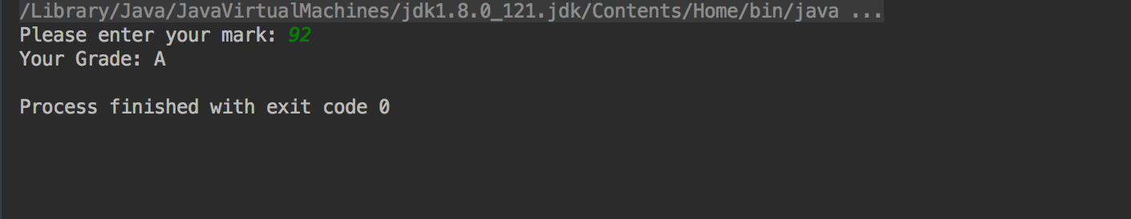

Question 3:

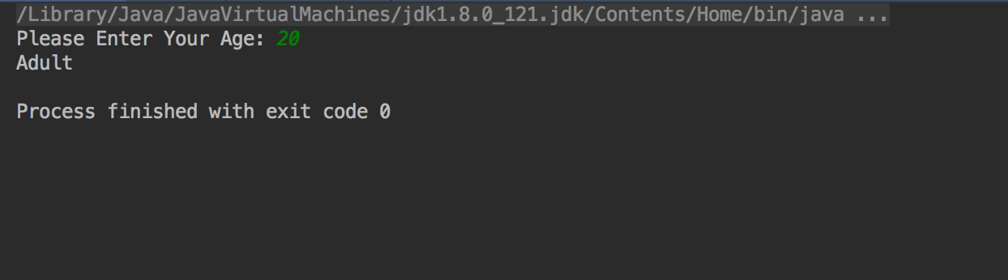

Question 4:

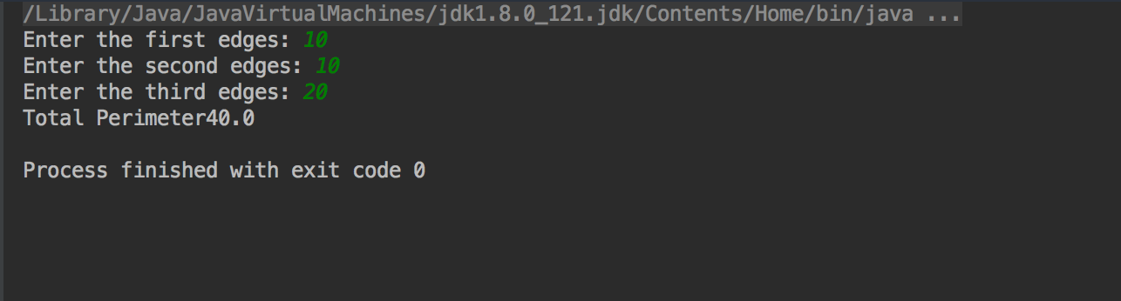

Question 5:

